TRADEZ
Ana Arellano Beltran
CST-451 Capstone Project Requirements Document
Grand Canyon University
Instructor: Professor Amr Elchouemi

Revision: 1
Date: 10/12/25

ABSTRACT

Tradez is a community driven web application designed to simplify and modernize the old practice of bartering. The platform would allow users to facilitate the exchange of goods and services without the need for money, fostering a more sustainable local economy. By integrating geolocation services, Tradez enables the users to connect with other traders nearby in the community, making local bartering more efficient. Additionally, for those users who prefer online interactions or more choices, an online section allows for remote trades, expanding the potential networks.

The main task of the project was to develop a user-friendly marketplace that promotes community without the need for monetary exchange. Some key features that will be included are user profiles, item listings with images, descriptions, category filters, chat functionality, and a rating system to ensure reliability and transparency. The interface will be built with a focus on navigation, modern design, and smooth performance across devices. Backend will be implemented to manage authentication, data storage, and location-based searches efficiently.

Tradez accomplishes the goal of bringing traditional barter systems with modern digital tools. It will empower those in the community to exchange without financial constraints and help others. It will reduce waste through item reuse and encourage community interaction. Tradez represents a meaningful step toward a more circular and connected economy, one where people trade not just goods but trust and mutual benefit.

History and Signoff Sheet
Change Record
Date | Author | Revision Notes
10/12/25 | Ana Arellano Beltran | Initial draft for review/discussion
4/10/26 | Ana Arellano beltran | Updates to Technical Requirements

Overall Instructor Feedback/Comments

Overall Instructor Feedback/Comments
Integrated Instructor Feedback into Project Documentation
☐ Yes ☐ No

TABLE OF CONTENTS
Functional Requirements 5
Non-Functional Requirements 6
Technical Requirements 7
Logical System Design 8
User Interface Design 9
Reports Design 12

Functional Requirements
Use Cases
Describe the sequence of functional actions a project performs with either textual Use Cases, UML Use Case diagrams, or if using Scrum, provide a link to the User Stories (see template included in course materials).
CST-451 Tradez Sprints Log.xlsx
NOTE: Once the functional requirements have been completed, there may be situations where Use Cases or User Stories may need to be taken out of scope, possibly due to technical challenges or timeline challenges. Any Use Cases or User Stories that are taken out of scope once the project development has started must be approved by the mentor and instructor with justification as to why the functionality is being removed from the project. The following must be updated if any Use Cases or User Stories are taken out of scope:

Use Case or User Story | Approval Date | Justification

NOTE: If necessary, you may add subsections to those listed in order to match the requirements in the assignment description. Do not remove any top-level sections (those that are listed in the Table of Contents). As required by your project, you may add additional top-level sections (please update the Table of Contents).

Non-Functional Requirements
Use Cases
Describe the sequence of non-functional actions a project performs with either textual Use Cases, UML Use Case diagrams, or if using Scrum, provide a link to the User Stories (see template included in course materials).
CST-451 Tradez Sprints Log.xlsx
NOTE: Once the non-functional requirements have been completed, there may be situations where Use Cases or User Stories may need to be taken out of scope, possibly due to technical challenges or timeline challenges. Any Use Cases or User Stories that are taken out of scope once the project development has started must be approved by the mentor and instructor with justification as to why the functionality is being removed from the project. The following must be updated if any Use Cases or User Stories are taken out of scope:

Use Case or User Story | Approval Date | Justification

Technical Requirements
Use Cases
Describe the tools and technologies used in the project.

The Tradez application is being developed as a full-stack web platform using modern technologies to ensure a responsive, secure, and scalable system. The front end will be built using HTML, CSS, JavaScript, and Thymeleaf, providing a dynamic server-rendered interface integrated directly with the backend. This will create a clean and friendly interface that will work across different browsers and screen sizes. The backend is implemented using Java Spring Boot, which manages server-side logic, REST endpoints, authentication, and overall application processing. The system uses MySQL as its relational database to securely store and manage user data, including profiles, item listings, messages, trade requests, and reviews in a structured format. To ensure security, user authentication is handled using BCrypt for password encryption, ensuring that all credentials are securely hashed and stored. I have done some research on geolocation technology and, so far, have leaned towards the W3C Geolocation API to support my location-based search and added listings. I plan to develop the project in Visual Studio Code, as I am familiar and comfortable with the integrated development environment.

NOTE: Once the technical requirements have been completed, there may be situations where technologies or tools may need to be taken out of scope or changed, possibly due to technical challenges or timeline challenges. Any technologies or tools that are taken out of scope or changed once the project development has started must be approved by the mentor and instructor with justification as to why the functionality is being removed from the project. The following must be updated if any technologies or tools are taken out of scope or changed:

Technology or Tool | Approval Date | Justification

Logical System Design
Provide a diagram of the logical architecture of the system.

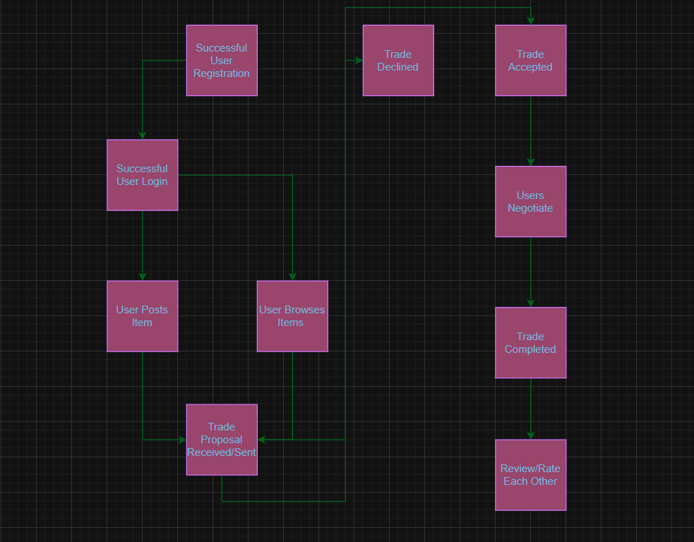
User Interface Design
Provide a sitemap and user interface design diagram for each user interface screen in the application, if not applicable, define the components of the project as described in the handbook.

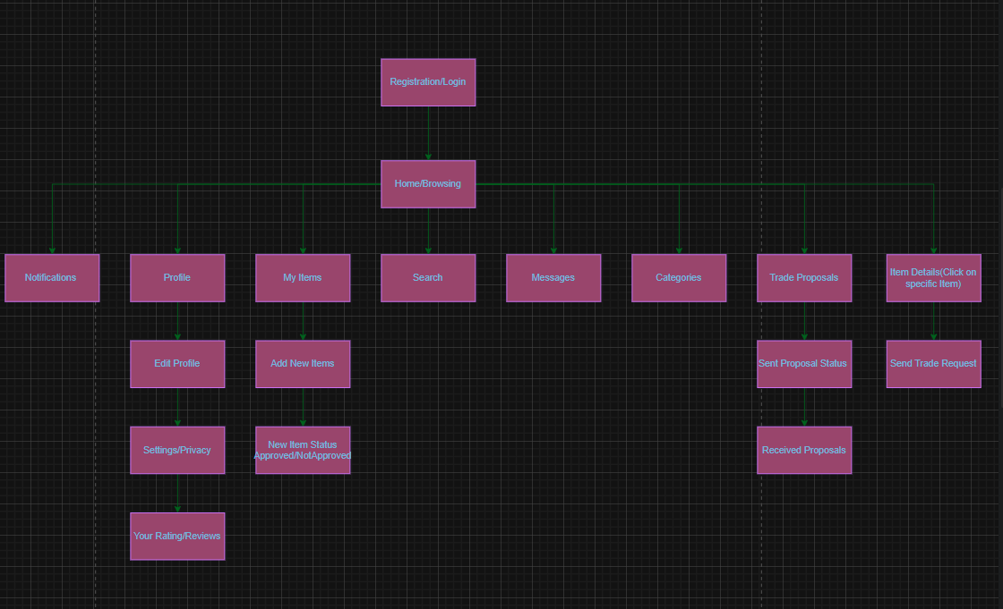

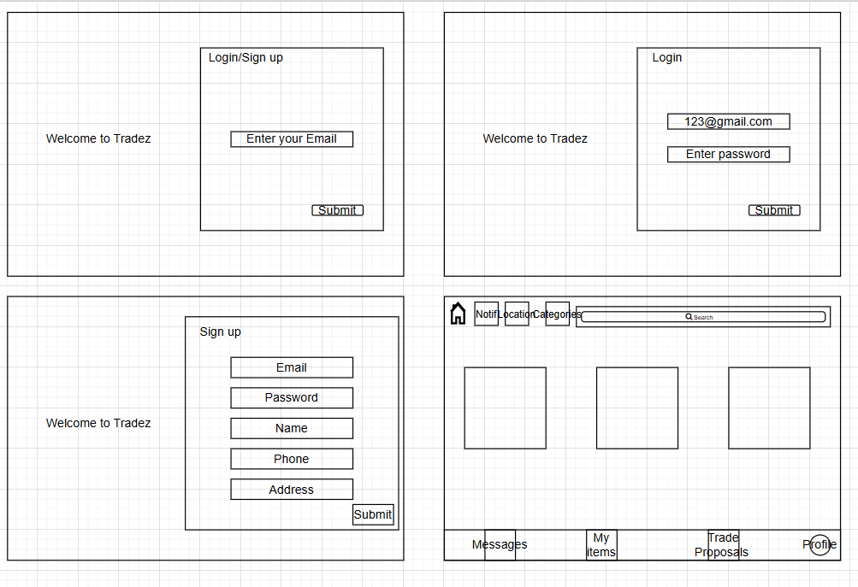
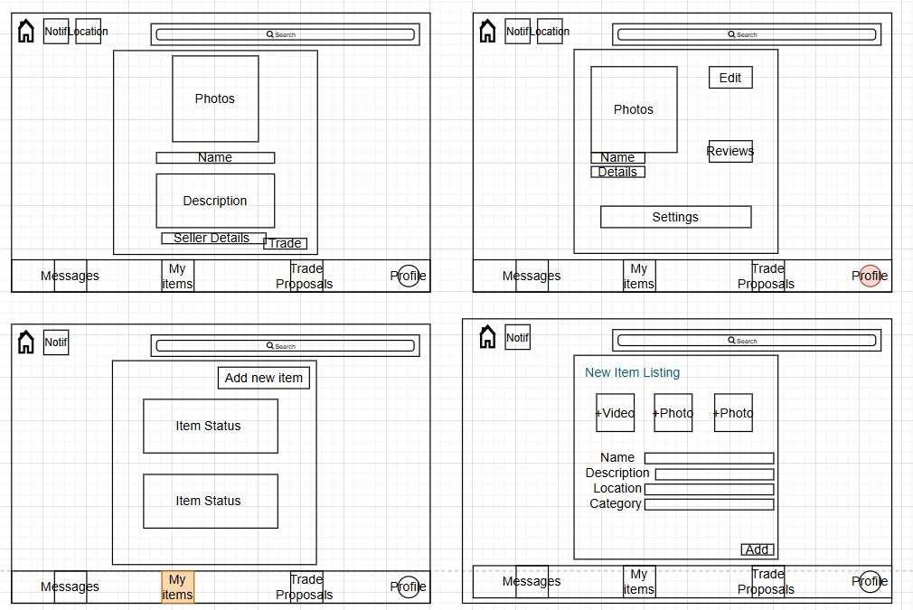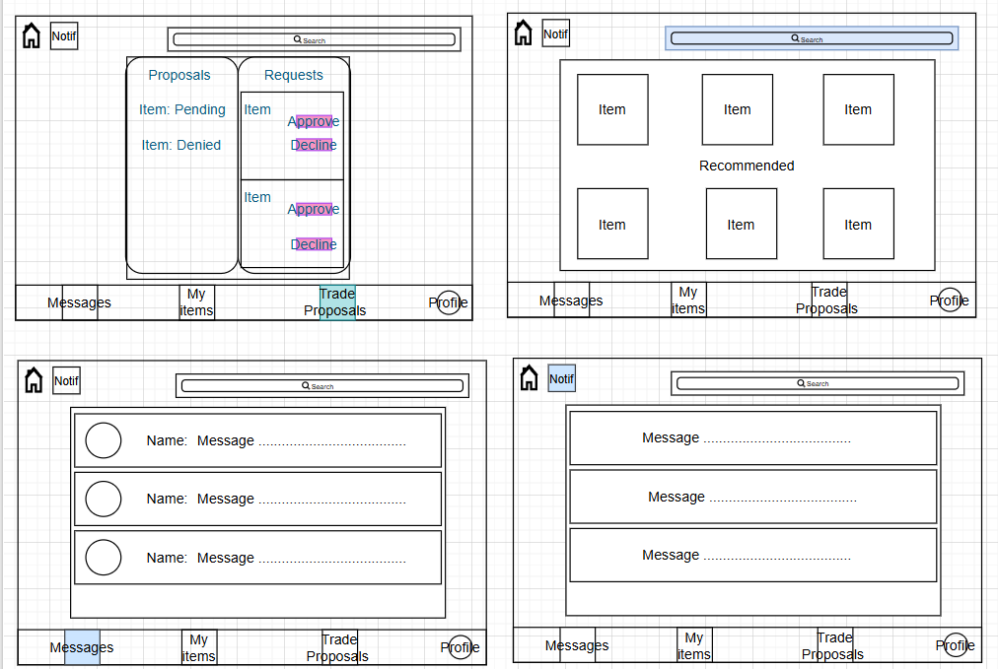
Reports Design
Provide a listing of the reports that the system will provide, if applicable. If not, state that the system does not produce any reports and provide additional documentation as described in the handbook.

